# DATA VISUALIZATION

**Data Analysis Objective**

The objective of this data analysis is to predict the purchasing behavior of different customers for the products offered by the store. By understanding which types of customers are more likely to make purchases, the store aims to establish user profiles and target potential customer groups, thereby enhancing product sales.

**Data Characteristics**

1. The top ten customers in terms of purchase volume are concentrated in City Type A.

2. Unmarried males are identified as a potential customer segment for the store.

3. Customers with Occupation 4 are potential users of the products.

4. City Type B represents a potential market for the store's expansion.

5. Customers' purchasing power tends to increase initially with age and duration of residence, followed by a decline.

**Dashboard Layout and Display Modes**

The overall layout of the dashboard is as follows:

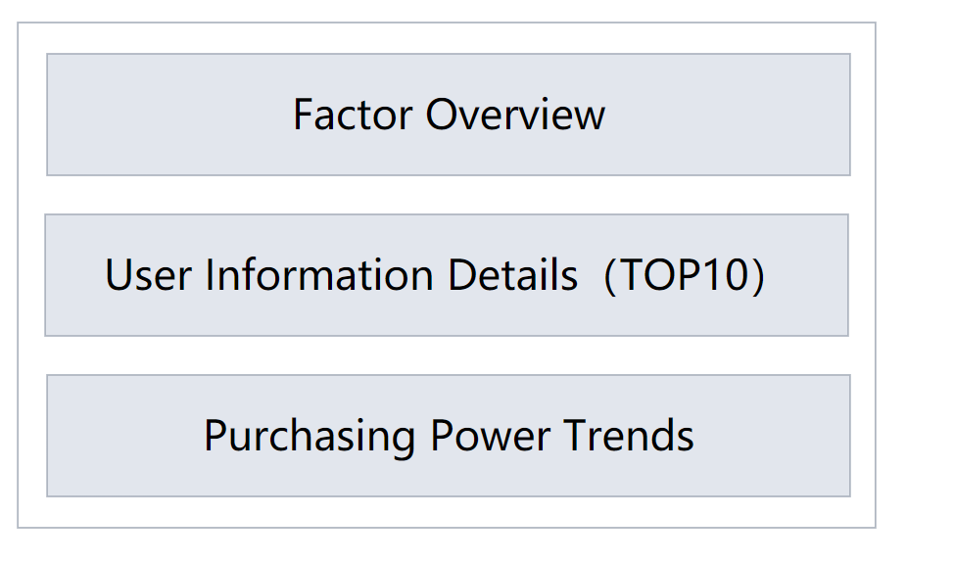

**TOP：Factor Overview**

The top section of the dashboard provides an overview where the purchase proportion can be viewed based on different user information factors. It helps the store to quickly understand the specific factors influencing purchases volume and their proportions..

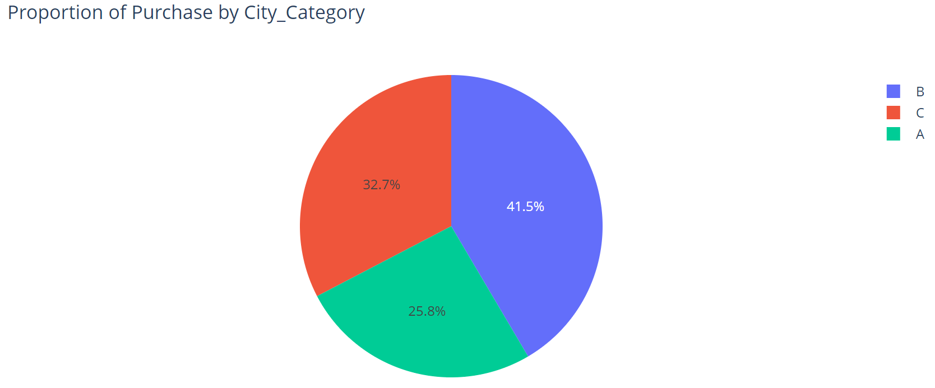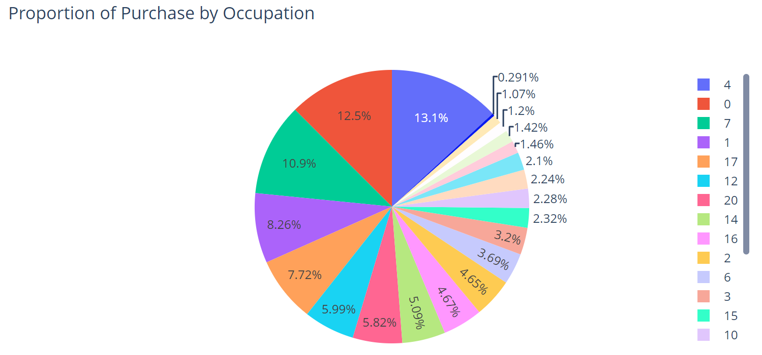

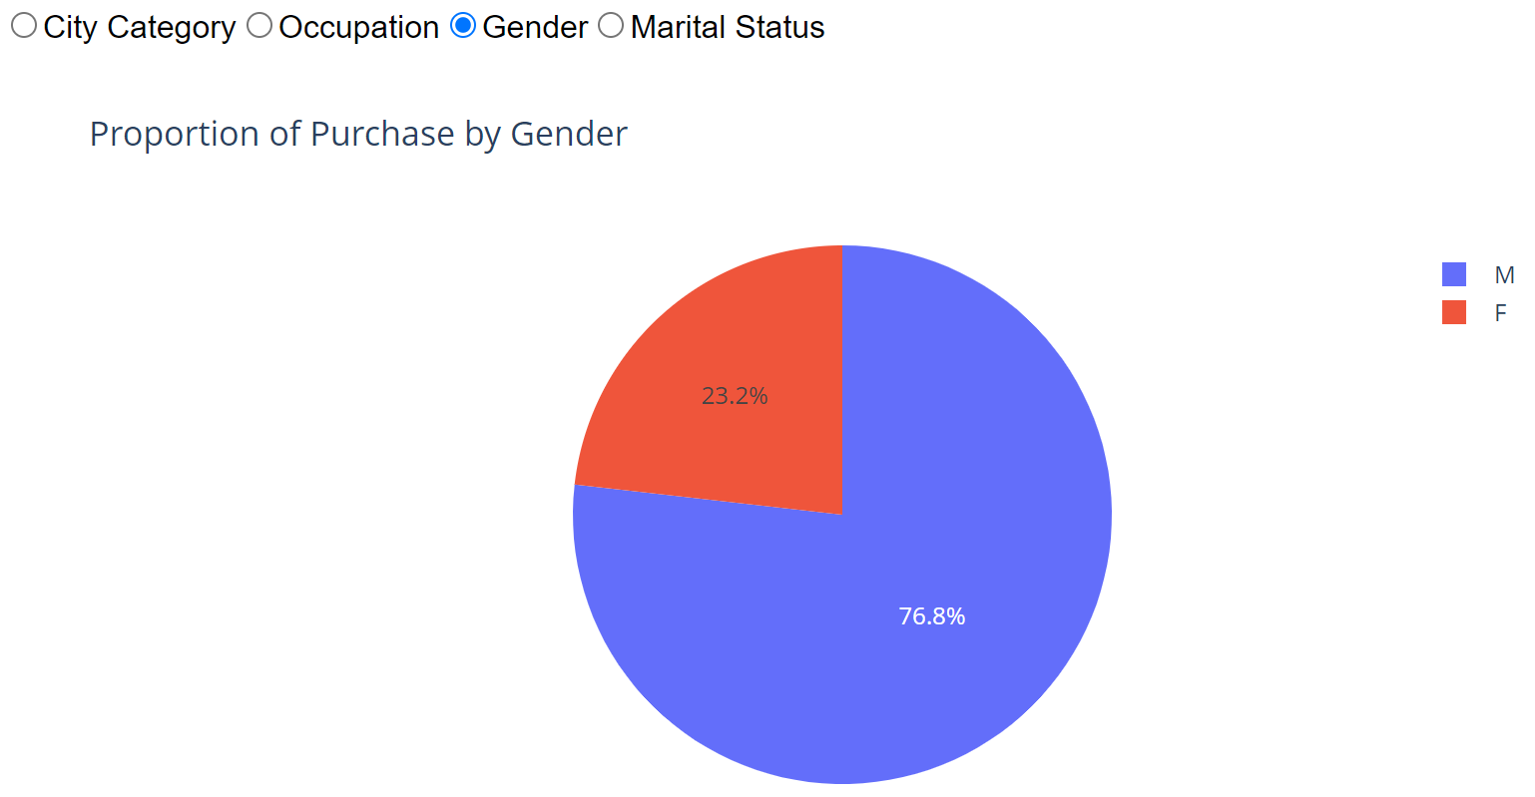

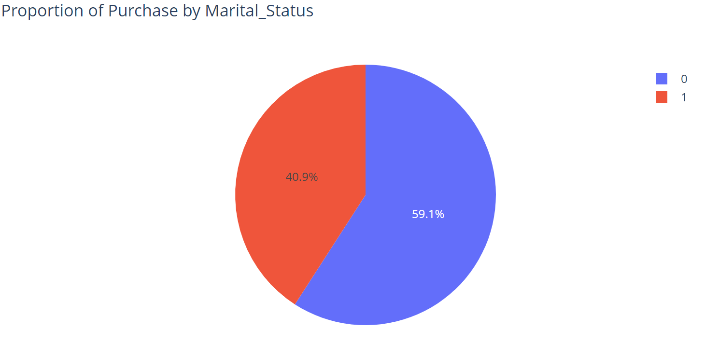

From the above four bar charts, it can be inferred that：

* customers from City Category B have the highest potential purchasing power.
* Customers with Occupation 0 and Occupation 4 have the highest potential purchasing power.
* Male and unmarried customers have the highest potential purchasing power.

**MIDDLE：User Information Details**

The middle section of the dashboard displays detailed information. By filtering the top ten customers based on purchasing power, the store can examine their specific personal information, assisting in the creation of typical user profiles.

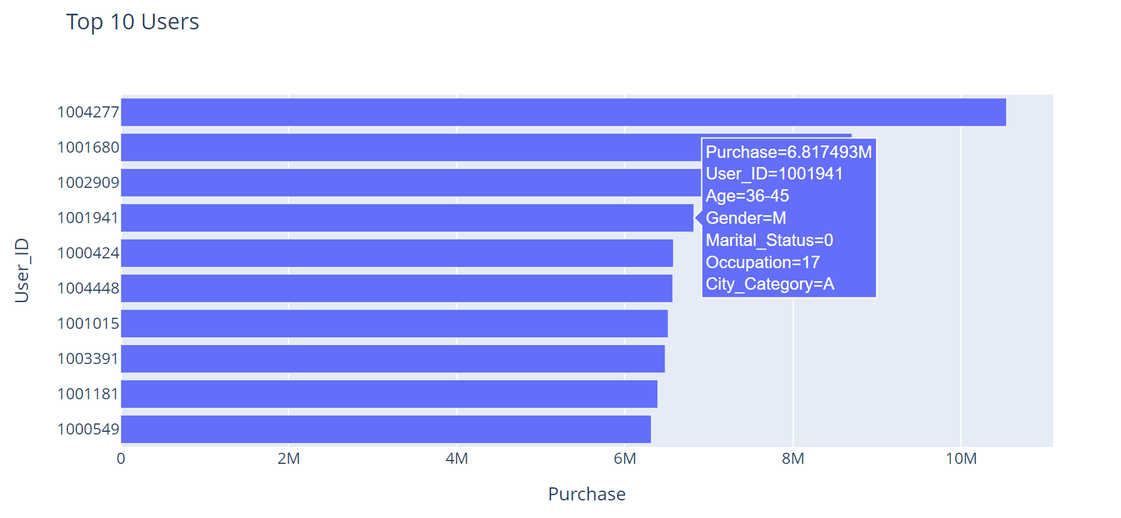

**BUTTOM：Purchasing Power Trends**

The bottom section of the dashboard presents future development trends. It allows the store to observe the changes in customer purchasing power with respect to age and duration of residence, enabling better sales strategies tailored to different time periods.

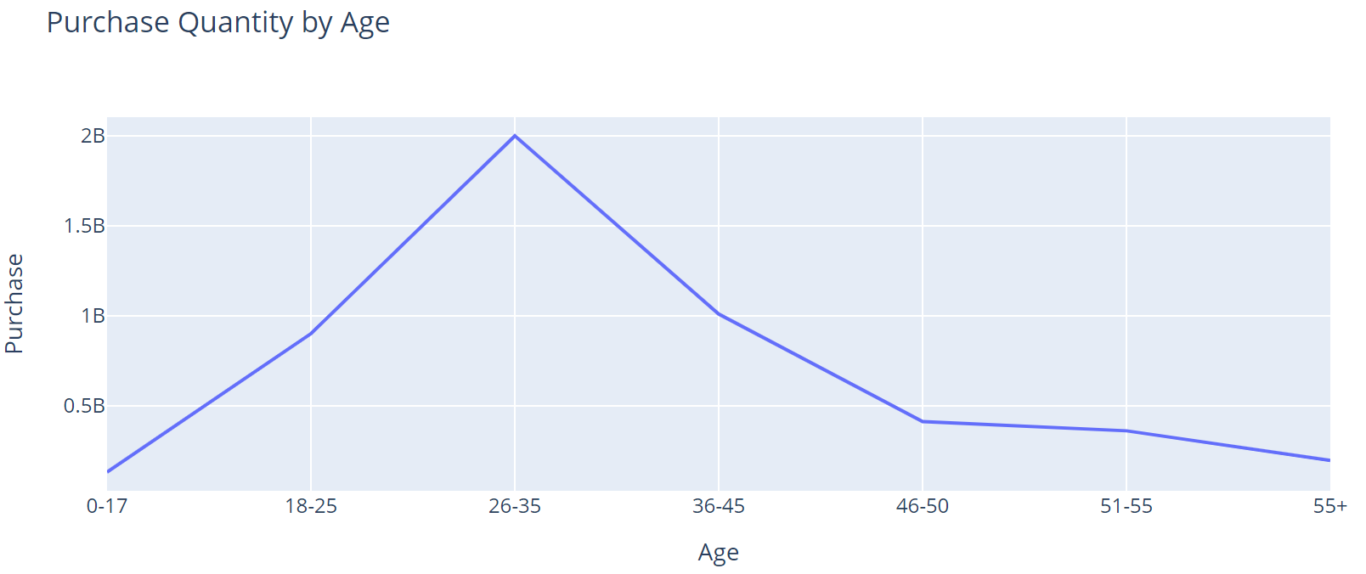

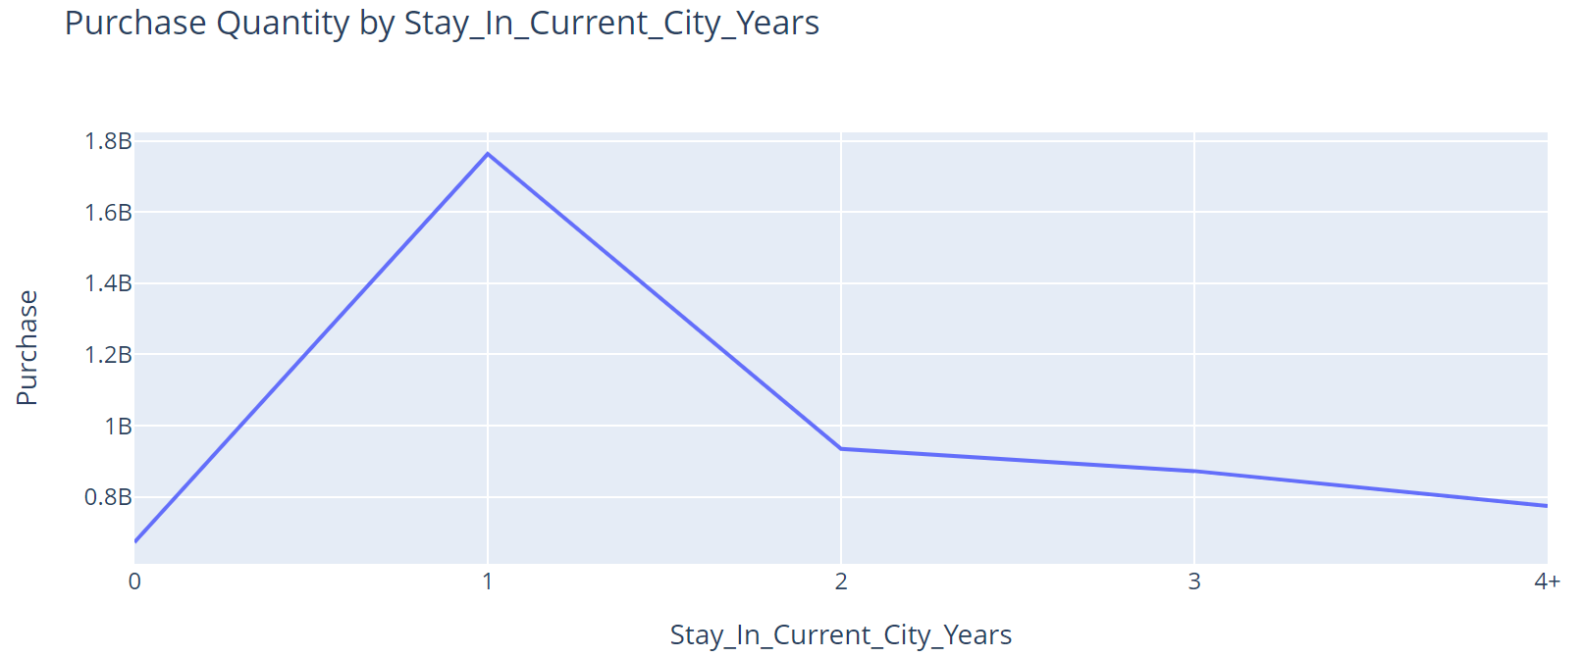

From the above two line charts, it can be observed that customer purchasing power shows a general trend of initially increasing and then decreasing as age and duration of stay in the current city increase. Among them, customers in the age range of 26-35 and with a duration of 1 year in the current city have the highest purchasing potential.